Milí rodiče, milé děti,

doufám, že je to poslední týden, na který vám posílám úkoly a příští už se sejdeme ve škole. Už se na vás moc těším.

Tady je shrnutí na celý týden, ale dílčí úkoly dostáváte z hodiny na hodinu, však už to víte. Takže se budete řídit tím, co vám zadám na online hodině.

**ČESKÝ JAZYK**

Učebnice – str. 36 -38

PS – 28 - 31

Procvičování pravopisu – str. 3

Čítanka 3 (opice) str. 36

**MATEMATIKA**

Učebnice – str. 26 -30

PS – 13 – 16

Geometrie – str. 9

**PRVOUKA**

PS str. 22, 20

**DV 6, Aj 3.ročník (od 23.11 do 27.11)**

Ahoj děti,  
posílám práci na další týden😊  
Tento týden už mi nebudete nic posílat. Doplníte si všechny úkoly, které vám chybí!!!  
Vše budeme společně opakovat a procvičovat na našich on-line hodinách.

**Zapište si do slovníčků:**  
**It´s stormy Je bouřka  
It´s hot. Je horko.  
It´s a rainbow. Je duha.**  
**1. ON – line hodina:**

Budeme neustále trénovat odpovědi na otázky:  
1. What´s your name?  
2. How old are you?  
3. How are you today?  
4. What day is it today?  
5. What´s the weather like?

**1. What is the weather like?**





|  |  |  |  |
| --- | --- | --- | --- |
|  |  |  |  |
| It's windy  It's raining  It's sunny It's snowing | It's windy  It's raining  It's sunny It's snowing | It's windy  It's raining  http://www.fotosearch.com/bthumb/UNC/UNC265/u19002365.jpgIt's sunny It's snowing | It's windy  It's raining  It's sunny It's snowing |







|  |  |  |  |
| --- | --- | --- | --- |
| It's sunny  It's stormy  It's raining  It's snowing | Overcast-icon.pngIt's sunny  It's cloudy  It's foggy.  It's snowing | It's sunny  It's windy  It's a rainbow  It's snowing | It's hot  It's windy  It's raining  It's snowing |

**2. ON – line hodina  
- pokračujeme v procvičování**

**3. Look at the map and describe the weather in each city*:***

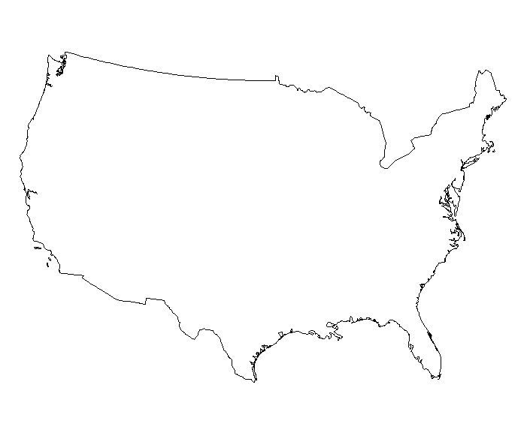





**Seattle**

**Chicago**



**Boston**



**Denver**

**Sacramento**



**Atlanta**

**Las Vegas**





**Dallas**

**Miami**

1. **The weather in *Miami* is .**
2. **The weather in *Denver* is .**
3. **The weather in *Chicago* is .**
4. **The weather in *Las Vegas* is .**
5. **The weather in *Dallas* is .**
6. **The weather in *Sacramento* is .**
7. **The weather in *Atlanta* is .**
8. **The weather in *Seattle* is .**
9. **The weather in *Boston* is .**

**Procvičujeme:**a) I have got – já mám  
b) He has got – on má  
c) She has got – ona má

**SAMOSTATNÁ PRÁCE:**   
zapisujte si do tabulky den v týdnu a počasí😊

|  |  |  |  |  |  |
| --- | --- | --- | --- | --- | --- |
| C:\Users\Ludzik\Desktop\Downloads\images.jpg | C:\Users\Ludzik\Desktop\Downloads\pobrane (1).jpg | C:\Users\Ludzik\Desktop\Downloads\pobrane (2).jpg | C:\Users\Ludzik\AppData\Local\Microsoft\Windows\Temporary Internet Files\Content.IE5\QYYX9TFV\MC900331453[1].wmf | C:\Users\Ludzik\Desktop\Downloads\stock-footage-seamless-loop-of-fog-or-smoke-drifting-over-a-black-background.jpg | C:\Users\Ludzik\Desktop\Downloads\pobrane.jpg |

SUNNY CLOUDY RAINING SNOWING FOGGY WINDY

|  |  |  |
| --- | --- | --- |
| Date | Weekday  den v týdnu | Weather  **počasí** |
| 23 rd November |  |  |
| 24 th November |  |  |
| 25 th November |  |  |
| 26 th November |  |  |
| 27 th November |  |  |
| 28 th November |  |  |
| 29 th November |  |  |